CHAPTER II: REVIEW OF RELATED LITERATURE AND STUDIES
This chapter reviews literature and studies relevant to the architectural design and functional deployment of PasaHERO. It establishes a critical academic foundation by examining existing multimodal transit information systems, the digitization of informal public transportation networks such as public utility jeepneys, and the role of Passenger Information Systems (PIS) in mitigating commuter anxiety. By analyzing these existing localized frameworks and algorithmic routing paradigms, this review justifies the development of PasaHERO’s specialized "Transportation Mode" and provides a technical rationale for its AI-driven route mapping, land-marked step-by-step guidance, and real-time fare estimation matrix within the unique transit landscape of Cebu City.

Related Literature
This chapter presents literature relevant to the development of PasaHERO: Multimodal AI Navigation with Jeepney Route Visualization and Fare Analytics in Cebu City. It reviews five themes: public transportation in developing countries and the Philippines; route navigation and mapping systems; fare computation technologies; artificial intelligence in transportation; and the gaps that justify PasaHERO. The approach and analysis are underpinned by established theories in transportation and technology adoption, including the Unified Theory of Acceptance and Use of Technology (UTAUT), Mobility as a Service (MaaS) frameworks, and the Sustainable Urban Mobility model. These frameworks guide the understanding of commuter behavior, technology integration, and urban transport improvements, establishing the theoretical and practical relevance of PasaHERO for Cebu City commuters.
Public transportation systems in developing countries often face limited digital infrastructure, fragmented services, and a lack of real-time information. Nirwana (2025) found that IoT, GPS, Intelligent Transportation Systems (ITS), and AI can improve transportation efficiency, but implementation is hindered by infrastructure and interoperability challenges. However, Nirwana’s study focuses mainly on macro-level technological obstacles and offers less insight into commuter-level adoption challenges and the specific needs of informal transport modes such as jeepneys. Yan (2026) similarly reported disconnected ticketing systems and inadequate real-time travel information, but did not address how these issues affect daily commuter decision-making or last-mile connectivity. In the Philippines, jeepneys remain the dominant mode of transportation despite limited digitization and poor access to route and fare information (Reyes et al., 2023; Nesnia, 2026). Existing research on jeepneys tends to emphasize infrastructural shortcomings but often lacks data on user experiences, technology adoption barriers, and practical digitization strategies for jeepney-centric systems.
Geographic Information Systems (GIS) and digital mapping technologies have become essential tools for improving commuter accessibility and route planning. Basnayake (2013) showed that GIS-based transit systems can provide route options, travel time estimates, and fare information. Krambeck (2015) emphasized that the lack of comprehensive transportation data hinders commuter decision-making and transport planning in the Philippine context. More recent studies integrated GIS with real-time tracking technologies, achieving high location accuracy and rapid notification delivery for passengers (Triyuliarsha et al., 2026). These findings justify including jeepney route visualization and digital mapping features in PasaHERO.
Fare transparency remains a major concern in informal transportation systems. Romanuke (2017) showed that GPS-based distance tracking can support automated and transparent fare computation. Assadifard (2014) likewise demonstrated that route-based distance calculations can determine accurate transportation fares. Recent automatic fare collection systems further show that QR codes, NFC, and RFID can enable faster, more transparent, and user-friendly fare management (Anand et al., 2025; Sonawane et al., 2025; Bhavani et al., 2025). These studies support the design of PasaHERO’s fare analytics component, which aims to provide clear, distance-based fare computation for traditional and modernized jeepneys.
Artificial intelligence has increasingly been applied to transportation systems to improve efficiency, personalization, and commuter experience. Koppala et al. (2025) demonstrated AI-driven route matching to optimize transportation services, while Suksomkit et al. (2025) showed that intelligent transit platforms can enhance transparency and user trust. AI applications have also expanded into route optimization and hazard-aware navigation. Betchayda et al. (2025) developed a flood-aware navigation system that reroutes users based on environmental conditions, while Daba-ay et al. (2025) implemented an AI-powered passenger occupancy monitoring system for modern jeepneys in the Philippines. These studies highlight the growing role of AI in smarter transportation systems and support the use of AI in PasaHERO’s route recommendations and commuter alerts.
Despite significant advancements, existing transportation applications still exhibit important limitations. Many systems focus solely on route tracking, fare management, or vehicle monitoring without integrating these features into a single commuter-centered platform. Applications such as iBiyahe and JeePoint provide route information and GPS tracking but lack comprehensive fare analytics, multimodal navigation, and AI-powered recommendations tailored to commuter needs (Fraginal et al., 2024; Pocaan et al., 2025). Specifically, iBiyahe’s platform offers mainly static jeepney route data and basic real-time location updates, while JeePoint focuses on driver and vehicle information and does not support automated fare computation or multimodal trip planning. In contrast, PasaHERO integrates jeepney route visualization, dynamic fare analytics, and AI-driven multimodal navigation into a single solution, offering personalized recommendations and an improved user experience for daily commuters. Cebu City’s jeepney system also remains underrepresented in existing research and technology solutions, which shows why PasaHERO is both novel and necessary.
Overall, the reviewed studies provide strong support for the development of PasaHERO. Research consistently shows that commuters experience difficulties due to insufficient route information, unclear fare structures, and the lack of integrated digital transportation platforms (Nirwana, 2025; Yan, 2026; Nesnia, 2026). In Cebu City, unique commuter challenges further underscore the need for a new approach. The city’s jeepney network is extensive but often lacks digitized route information, leading to confusion for both locals and visitors. Frequent route adjustments, inconsistent vehicle availability, traffic congestion, and limited integration with other transit modes contribute to daily uncertainty for commuters. Fare calculation is also complicated by variable pricing based on distance and periodic regulatory changes, leading to unclear or disputed fares. GIS-based navigation systems, fare computation technologies, and AI-powered transportation applications have demonstrated their effectiveness in improving commuter experience and operational efficiency. PasaHERO addresses this gap by combining multimodal AI navigation, real-time jeepney route visualization, and fare analytics into a single platform specifically designed for Cebu City commuters, offering a more accessible, transparent, and intelligent public transportation experience.

Theoretical Foundation
The development of PasaHERO: A Multimodal AI Navigation with Jeepney Route Visualization and Fare Analytics in Cebu City is based on established theories and frameworks in transportation, information systems, and geographic technologies. These theories provide the conceptual basis for the system's navigation, route visualization, fare computation, and user acceptance.
Graph Theory
Graph Theory, established by Euler in 1736 and further developed in modern mathematics, is the study of graphs consisting of vertices (nodes) and edges (connections). In transportation systems, Graph Theory is commonly used to represent road networks, transit stops, and travel routes. Each destination or jeepney stop can be represented as a node, while the roads or jeepney routes connecting them are represented as edges. This representation allows navigation systems to organize transportation networks and determine possible travel paths between locations.
PasaHERO mainly bases on Graph Theory in organizing the jeepney transportation network of Cebu City. Jeepney stops, landmarks and destinations are represented as interconnected locations that enable the system to suggest routes, visualize jeepney paths on a digital map, and offer first-mile and last-mile navigation guidance.
Geographic Information System (GIS)
Geographic Information System (GIS) is a computer system that collects, manages, analyzes and visualizes geographical data. GIS combines spatial data, such as maps, coordinates, roads and landmarks, to aid in location-based decision-making. It has become an essential technology in the field of transportation planning because it allows the users to visualize the routes, determine locations and improve the accuracy of navigation.
PasaHERO uses GIS concepts such as digital maps, GPS location services and route visualization to help commuters traverse Cebu City’s jeepney network. The system displays color-coded jeepney routes, walking paths, boarding locations, drop-off points and nearby landmarks, enabling commuters to better understand their travel route and destination.

Rule Based System
A Rule-Based System is an AI method that relies on pre-defined rules or conditions to make decisions. The system uses logical “if-then” rules to produce consistent outputs instead of learning from data. Rule-based systems are widely used in transportation for fare computation, route classification and decision support.
PasaHERO utilizes rule-based computation of jeepney fares. The system computes estimated fares based on the official LTFRB distance-based fare matrix for traditional and modernized jeepneys. Commuters can get a transparent and consistent estimation of their fare before starting their journey, as fare rules are predefined.
Mobility as a Service (MaaS)
Mobility as a Service (MaaS) is a transportation concept that aims to provide seamless travel planning by integrating multiple transportation services into one digital platform. MaaS integrates walking, public transportation and other mobility options into one seamless journey, rather than treating each mode of transportation separately. This framework provides efficient, convenient and user-centric mobility.
PasaHERO’s multimodal navigation capability reflects the principles of MaaS. The app integrates walking directions for first-mile and last-mile travel with jeepney route recommendations, enabling commuters to plan end-to-end journeys from their current location to their final destination in one platform.
Unified Theory of Technology Acceptance and Use (UTAUT)
The Unified Theory of Acceptance and Use of Technology (UTAUT) developed by Venkatesh et al. (2003) explains the determinants of user acceptance and the intention to use new technologies. The model identifies four main determinants of technology adoption: performance expectancy, effort expectancy, social influence and facilitating conditions.
This theory is the basis for the evaluation stage of PasaHERO. The study assesses the functionality, usability, reliability, efficiency and user satisfaction of the system to determine the level of acceptability among commuters. These evaluation criteria are in line with the principles of UTAUT, emphasizing the importance of perceived usefulness and ease of use in technology adoption.

Related Studies
The researchers examined various studies on AI-driven navigation systems, multimodal public transportation routing algorithms, digital map-based jeepney route visualization, and fare calculation methodologies to evaluate and compare the breakthroughs of PasaHERO. The studies, derived from academic literature and transport planning resources, demonstrate how automated mobile technologies can alleviate transit anxiety, overcome severe information asymmetries in public transport, and enhance metropolitan mobility for newcomers and socially anxious travelers. Through an extensive analysis of related works, the researchers hope to uncover effective navigation strategies and critical digital gaps in localized public transport mapping, which PasaHERO aims to address through its integrated color-coded route overlays, dynamic fare analytics, and conversational AI guidance.
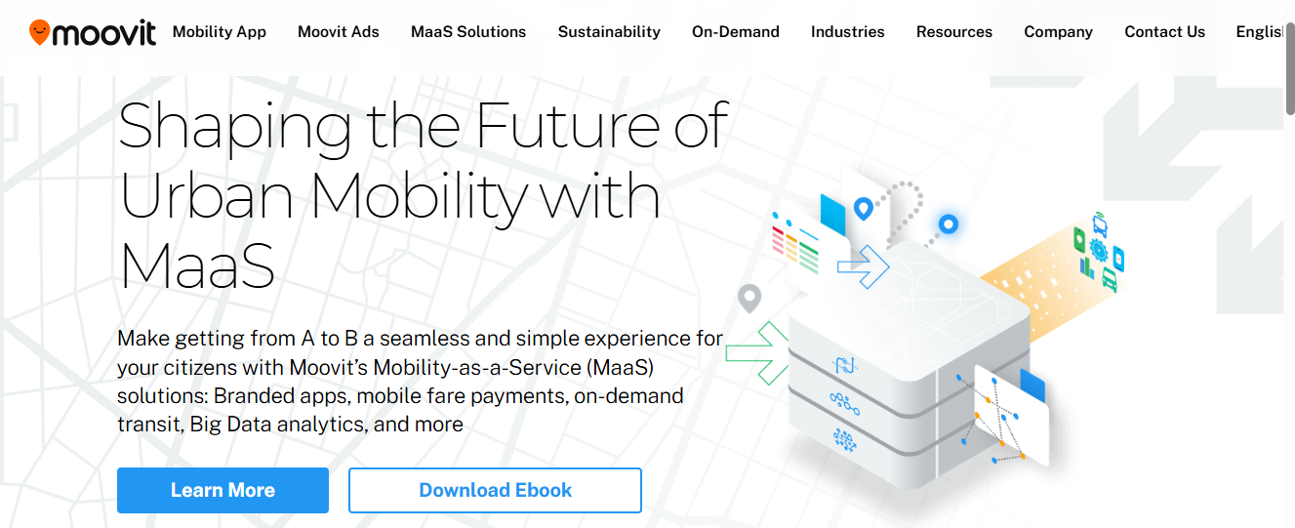
Figure 1: Moovit
Moovit is one of the world's leading public transit apps, available in over 100 countries and more than 3,500 cities. It combines various modes of transportation, including buses, trains, subways, and walkways, into a single commuting experience. It offers real-time arrival information, turn-by-turn navigation, and proactive notifications that alert users when they are approaching their stops. Moovit is the world's largest transit network, providing a reliable, commuter-focused experience that makes urban mobility easier and daily travel more efficient.

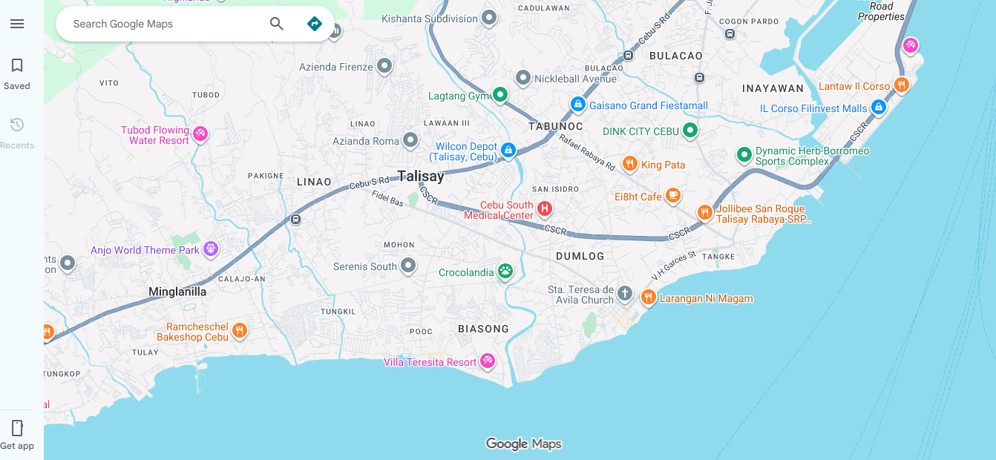

Figure 2: Google Map
Google Maps is the world’s most popular navigation service, offering detailed route suggestions by car, walking, cycling, and public transport. Its transit mode combines multiple modes of transport, providing users with estimated travel times and alternative routes to help them optimize their trips. Google Maps’ strength lies in its ability to combine real-time navigation with multiple modes of transport, making it a reliable and versatile tool for both daily commuting and long-distance travel.
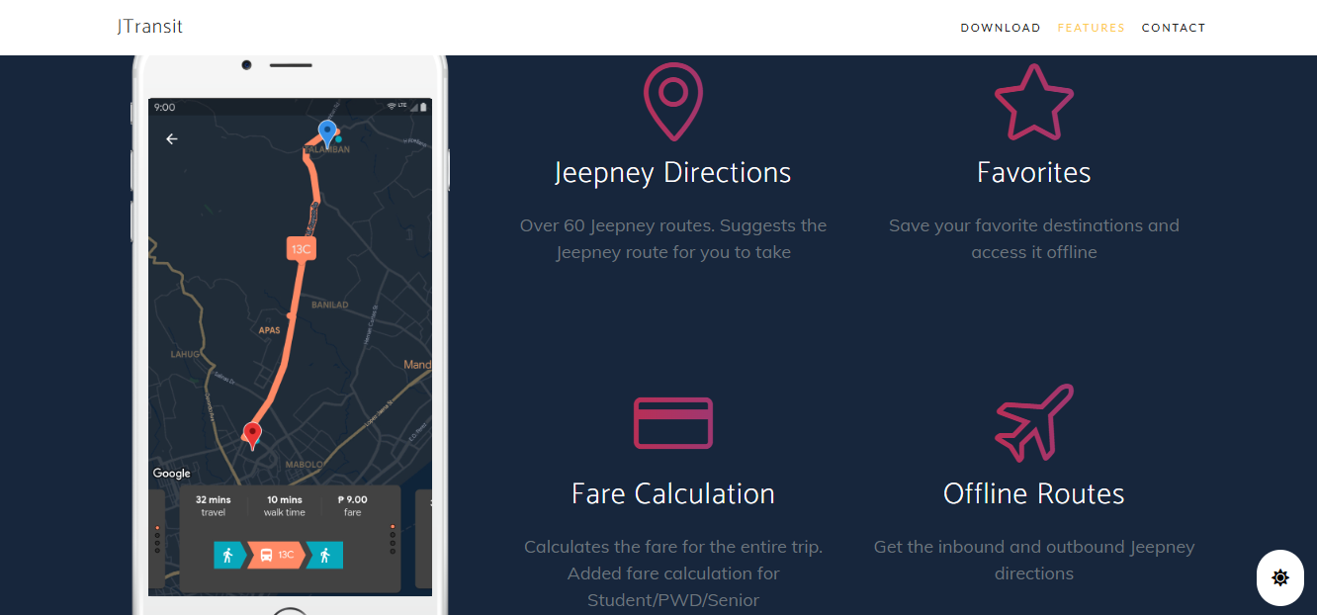
Figure 3: JTransit - Cebu Jeepney Navigation
JTransit is a Metro Cebu oriented Philippine native mobile application acts as a navigation app for users in the Philippines based commuters, which originated/made in Cebu. The app itself provides jeepney route suggestions that comprise over 60 Cebu jeepney routes, an automatic fare calculator, options for checking multiple trips at once, offline access to routes and approximate travel times. It provides the best jeepneys to take based on where the user is coming from and going, thus making commuting around Metro Cebu more efficient and less burdensome.
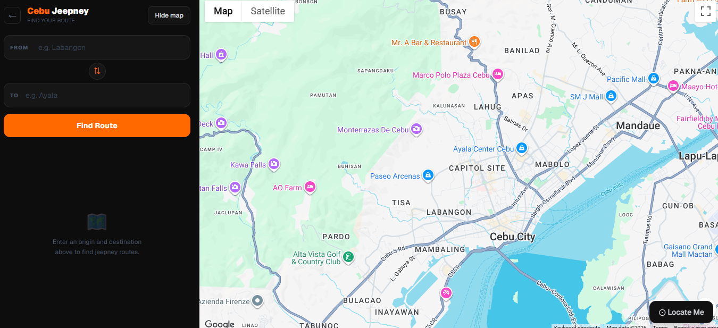
Figure 4: Cebu Jeepney Finder
Cebu Jeepney Finder is a web-based commuter guide that assists users find direct jeepney routes and transfers around Cebu. The platform provides access to 55 jeepney routes in Cebu and over 1,100 stops, with recommendations for transfers to make commuting more efficient. It also has the ease of use as it is non-registration, allowing users to easily browse the latest jeepney route information without any barriers.
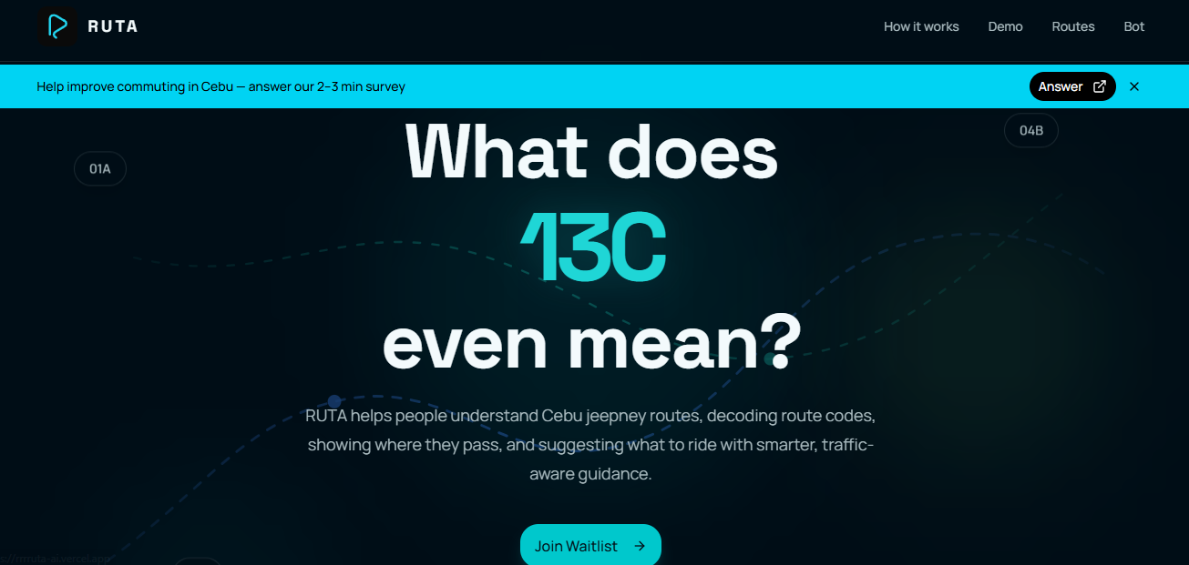
Figure 5: RUTA
RUTA is a Cebu-based commuter platform that aims to simplify the alphanumeric jeepney route codes in the city. It decodes codes like 17B, 04B, and 01A into easy-to-read route descriptions so commuters know which jeepneys to ride for their trips. It also suggests routes to help users travel smarter. RUTA is more than just decoding; it also focuses on commuter-friendly explanations and traffic-conscious suggestions, making it a practical tool for navigating Cebu’s busy transport network.

Comparative Matrix
The table below shows the differences and the comparisons between the system and the related studies
Table 1
COMPARATIVE MATRIX

Features | PasaHERO | Moovit | Google Maps | JTransit | Cebu Jeepney  Finder | RUTA
Multimodal Routing (Walking + Public Transport) | ✔ | ✔ | ✔ |  |  | ✔
Features | PasaHERO | Moovit | Google Maps | JTransit | Cebu Jeepney  Finder | RUTA
AI-Powered Route Optimization | ✔ |  |  |  |  | ✔
Cebu - Specific Jeepney  Navigation | ✔ |  | ✔ | ✔ | ✔ | ✔
Jeepney Route Recommendations | ✔ |  | ✔ | ✔ | ✔ | ✔
Jeepney Code / Signboard Recognition | ✔ |  | ✔ |  |  | ✔
Walking Directions to Boarding Points | ✔ | ✔ | ✔
Jeepney Route Visualization on Map | ✔ | ✔ | ✔
Automatic Fare Calculation | ✔ |  |  | ✔
LTFRB-Based Dynamic Fare Analytics | ✔
Landmark - Based Guidance | ✔
Geofenced “Para”  Notifications | ✔ | ✔
Color-Coded Route Overlay | ✔
First-Mile / Last-Mile  Guidance | ✔ | ✔ | ✔
Transfer Recommendations | ✔ | ✔ | ✔ | ✔ | ✔ | ✔
Tourist / Destination  Information | ✔ |  | ✔
Total | 100% | 40% | 60% | 26.67% | 20% | 40%

The comparative analysis revealed that PasaHERO achieved the highest score of 100%, indicating that all identified features were successfully integrated into a single commuter assistance platform. Among the existing systems, Google Maps obtained the highest feature coverage at 60.00%, demonstrating its strengths in navigation, route optimization, and multimodal transportation guidance. Moovit and RUTA each achieved 40.00%, with Moovit excelling in public transit navigation and commuter alerts, while RUTA provided AI-assisted jeepney route recommendations and code interpretation tailored to Cebu commuters. Meanwhile, JTransit and Cebu Jeepney Finder recorded 26.67% and 20.00%, respectively, as their functionalities were primarily limited to jeepney route lookup and localized commuter information. These findings highlight PasaHERO’s ability to address the limitations of existing systems by integrating AI-powered multimodal routing, Cebu-specific jeepney route visualization, signboard recognition, LTFRB-based fare analytics, landmark-assisted guidance, geofenced “Para” notifications, first-mile and last-mile navigation, and color-coded route overlays into a single comprehensive platform. Therefore, PasaHERO offers a more innovative and holistic approach to enhancing the commuting experience for both residents and visitors in Cebu City.

